Ubuntu

Ubuntu is an ancient African word meaning ‘humanity to others’. It was created by Mark Shuttleworth in 2004 and is one of the most widely used Linux distros for beginners.

Apps

LibreOffice
App Store
Terminal
‘Show applications’

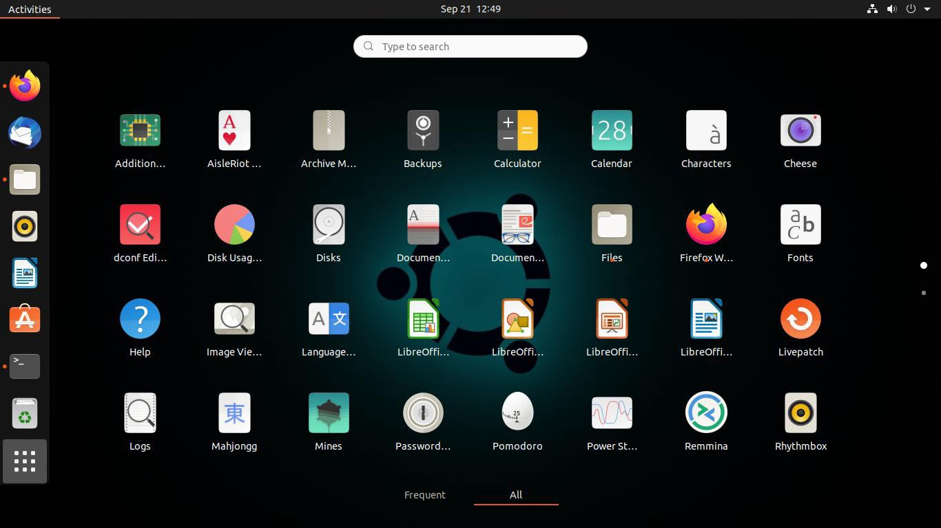

Package Installs

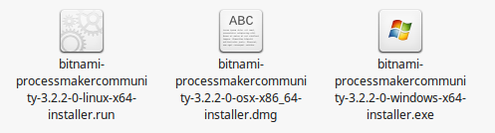
Some applications will not be readily available through the app store. Windows uses .exe and Mac uses .dmg as files for installation, but Linux has many different package formats.
These packages are essentially archives of files needed for download. Some additional package formats in linex are .deb, .rpm, and .tar.

